**PROJECT ON A AUTOMATIC SHOP CONTROLLING SYSTEM**

This is an Automatic Shop Controlling System developed using Java as programming language and MySQL the back end. It is developed to reduce time and control shop easily.

**Features:**

1. It is secured.
2. It is fast and confident.
3. Calculate results accurately and automatically.
4. User can add new product easily.
5. User can sale product easily.
6. User can see product price easily.
7. User can see product list easily.
8. User can search which product sold on specific date.

**HOW TO USE:**

User can access the main frame by using name and password. User also can update his/her password.

Login Interface

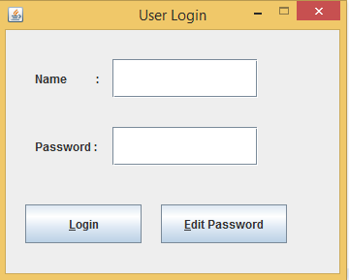

Change Password Interface

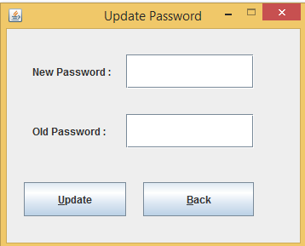

If username and password become correct

Main Frame Interface

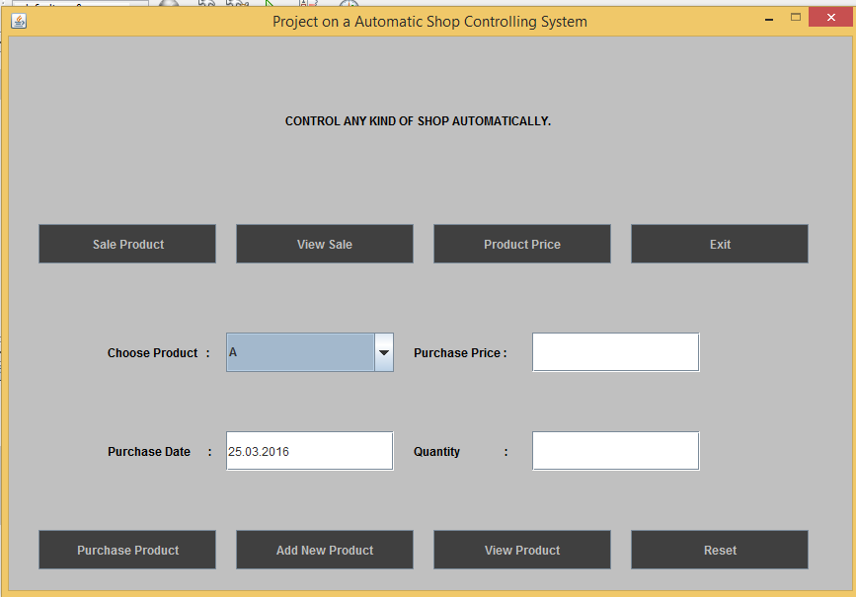

If purchase product information is not correct:

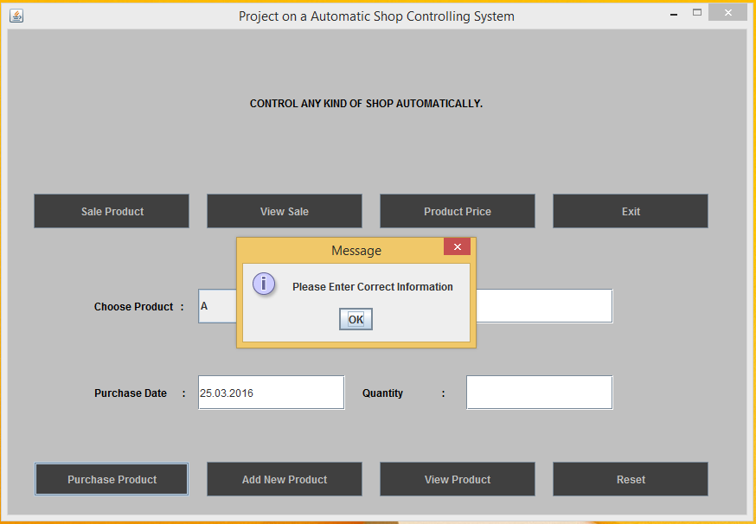

Screenshot (16).png

If purchase product information is correct:

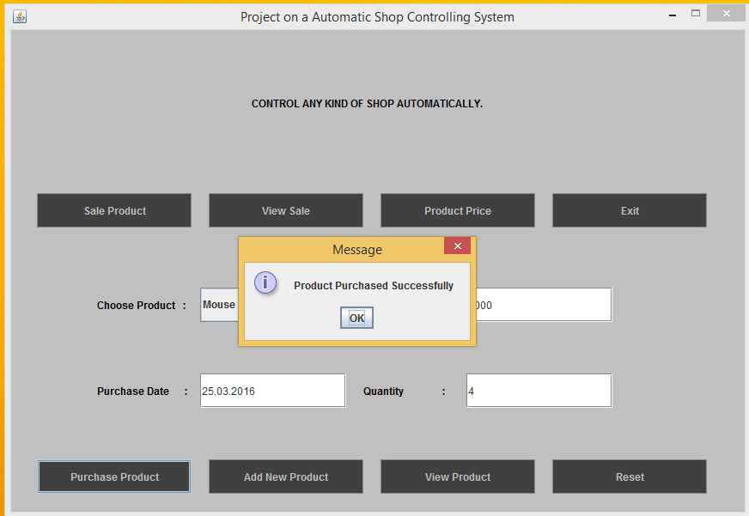

Sale Product and get total price:

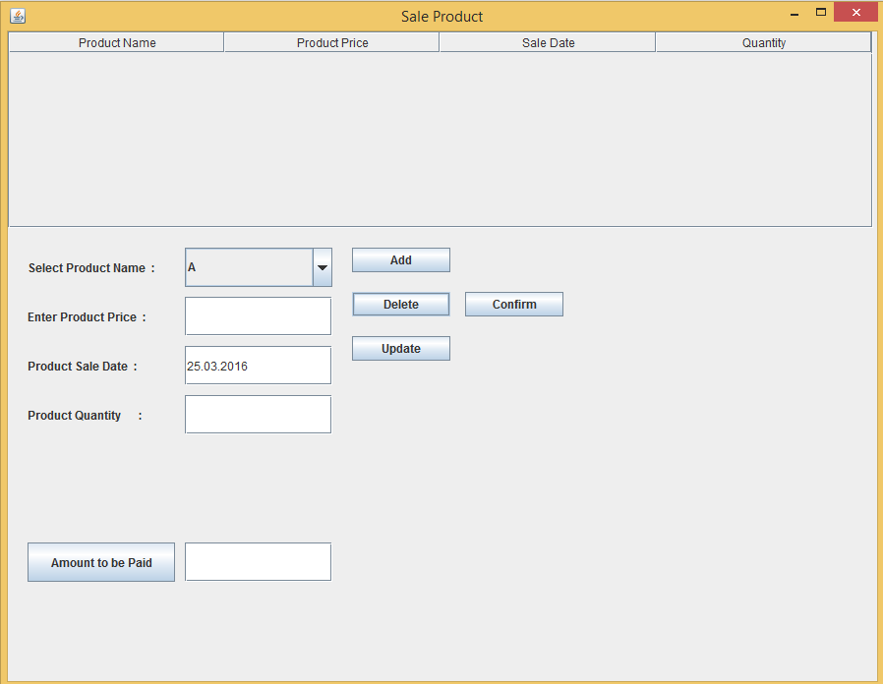

Search sale information on specific date:

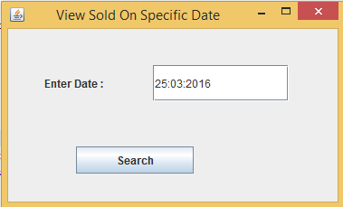

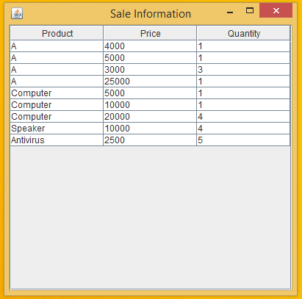

Get Products and Product average Price:

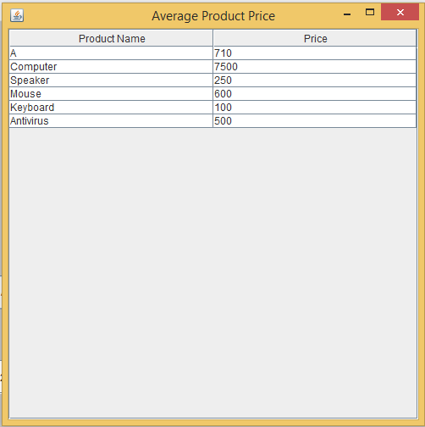

Add new Product to the list:

